Laughton Lodge Information Pack
Address: Laughton Lodge, Common Lane, Laughton, Lewes, East Sussex BN8 6BY
About the Venue:
Laughton Lodge is a co-housing community in the East Sussex countryside, established in 1998. It’s comprised of 22 homes of differing sizes and community buildings which house a dining hall, dance studio, music studio and office spaces.
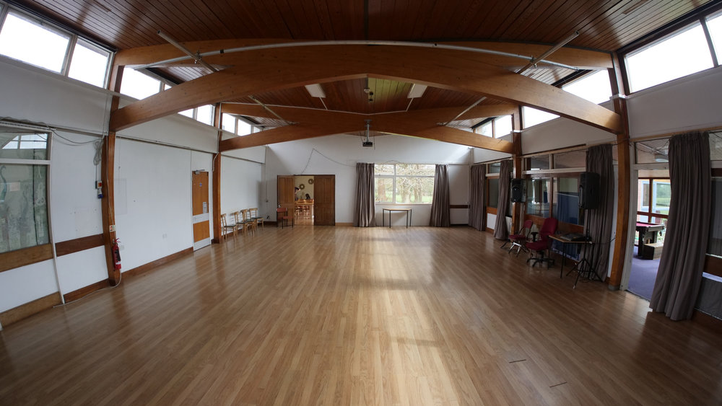
Dance Studio
A light and bright studio, with wooden floors, plenty of windows, use of a projector, sound system and basic lighting, making this the perfect creation studio for exploration and experimentation.
Dimensions: 12.8m x 8.7m
Music Room
A smaller space, ideal for solo/duet work.
Dimensions: 11m x 4m
Accommodation:
Accommodation is in the same building as the studios, with rooms in a private corridor and all communal rooms (e.g. kitchen, dining/lounge room) accessible through the main studio. Bed linen is provided but you will need to bring your own towel. There is a washing machine on site if you need to wash your clothes. Toilets/showers are shared by all guests and are just down the corridor from the rooms.
Rooms range from single to double beds, unfortunately not everyone will get a double. If you have any requirements or requests regarding accommodation, please don’t hesitate to get in touch.
Room 1 - sleeps two – one double bed, toilet, sink
Room 2 – sleeps four – one double bed, two bunk beds
Room 3 – sleeps two – two bunk beds, sink
Room 4 – sleeps one – one single bed, sink
Room 5 – sleeps one – one single bed, desk, and chair
Kitchen & Dining:
You will have full access to the Shawfield ‘big’ kitchen, accessible directly through the main studio. There are fridges and cupboards where you can store your food items.
There is a cleaner that comes once a week to clean all communal areas in Shawfield, but you will be responsible for your own washing up and generally keeping the spaces you are using clean and tidy.
There is a barista style coffee machine in the dining room.
There are no shops within walking distance so please bring anything specific that you will need. The Roebuck Inn pub (25 minute walk) is open every day from 9am-11pm.
Getting here:
Travelling by car – there is a large car park on site which is shown in the map at the end of this document.
Travelling by train – The nearest train stations are Uckfield and Lewes. Unfortunately, neither is within walking distance. Public transport is not frequent in this area, so we recommend you planning in advance.
A company we use regularly are DB Taxis and can be contacted on 01825 890 375 or 07807 228 612.
Suggested list of items to bring with you:
- Warm clothes for the evenings
- Toiletries
- Towel
- Torch (if you have one)
- Comfortable shoes to walk in
Important Info:
Laughton Lodge is a co-housing community, and therefore we ask that during your stay you are mindful that this is people’s homes.
In addition to the two rehearsal studios, Shawfield also houses many offices and co-working hot-desk areas. Whilst you rehearse, you are welcome to use the hot-desk area.
Laughton Lodge is in a rural location, there is Wifi but connection can be slow and phone signal can be limited. Laughton Lodge is mostly residential, so please be mindful of that.

Map of Laughton Lodge

